GRAND PERFORMANCE TASK: UI/UX & INTERACTION DESIGN
Project Title: OpsAI: Smart Inventory SaaS Interface
Student Name: Hazel Arana
Design Method: Digital Prototype (Figma)
Date: March 14, 2026

Part 5: Interaction Design Principles
The OpsAI interface applies core interaction design principles by utilizing a clear, card-based conceptual model that drastically reduces cognitive load. Navigation is anchored by a persistent left-hand sidebar, ensuring users always maintain a clear mental model of their location within the system. To support effective interaction, the layout follows Fitts's Law by making primary call-to-action buttons (such as "Add Resource" or "Login") large, distinct, and easily clickable.
Furthermore, the design deeply considers user needs and behavior by anticipating daily workflows. Instead of burying features inside complex menus, the system surfaces critical, time-sensitive data—such as system overviews and recent activity—directly on the main dashboard. The inventory management table allows for quick scanning of data, minimizing the number of clicks required to complete standard operational tasks, thereby maximizing efficiency and overall usability.

Part 6: Emotional Interaction in Design
The interface actively shapes a positive emotional interaction by employing a clean, modern aesthetic with a calming color palette (deep blues, soft grays, and crisp whites) to reduce workplace anxiety and prevent visual fatigue. To avoid annoying design elements, the system abandons disruptive modal pop-ups, opting instead for polite, temporary notifications to confirm user actions. Furthermore, status indicators use universally understood semantic colors—green for "In Stock" and red for "Out of Stock". This predictable, clear feedback loop prevents user frustration, builds trust, and encourages positive, confident engagement with the system.

Part 7: Interface Type
The OpsAI system utilizes a Web-Based Graphical User Interface (GUI). This interface type is highly suitable for a SaaS platform because it allows users to interact with familiar visual metaphors—such as digital dashboards, icons, and buttons—using standard pointing devices. A Web GUI ensures the platform is universally accessible across different operating systems and devices without requiring complex software installations, making it highly practical and efficient for fast-paced modern workplaces.

Part 8: Interface Designs and Prototypes
Figure 1 – OpsAI Login Interface
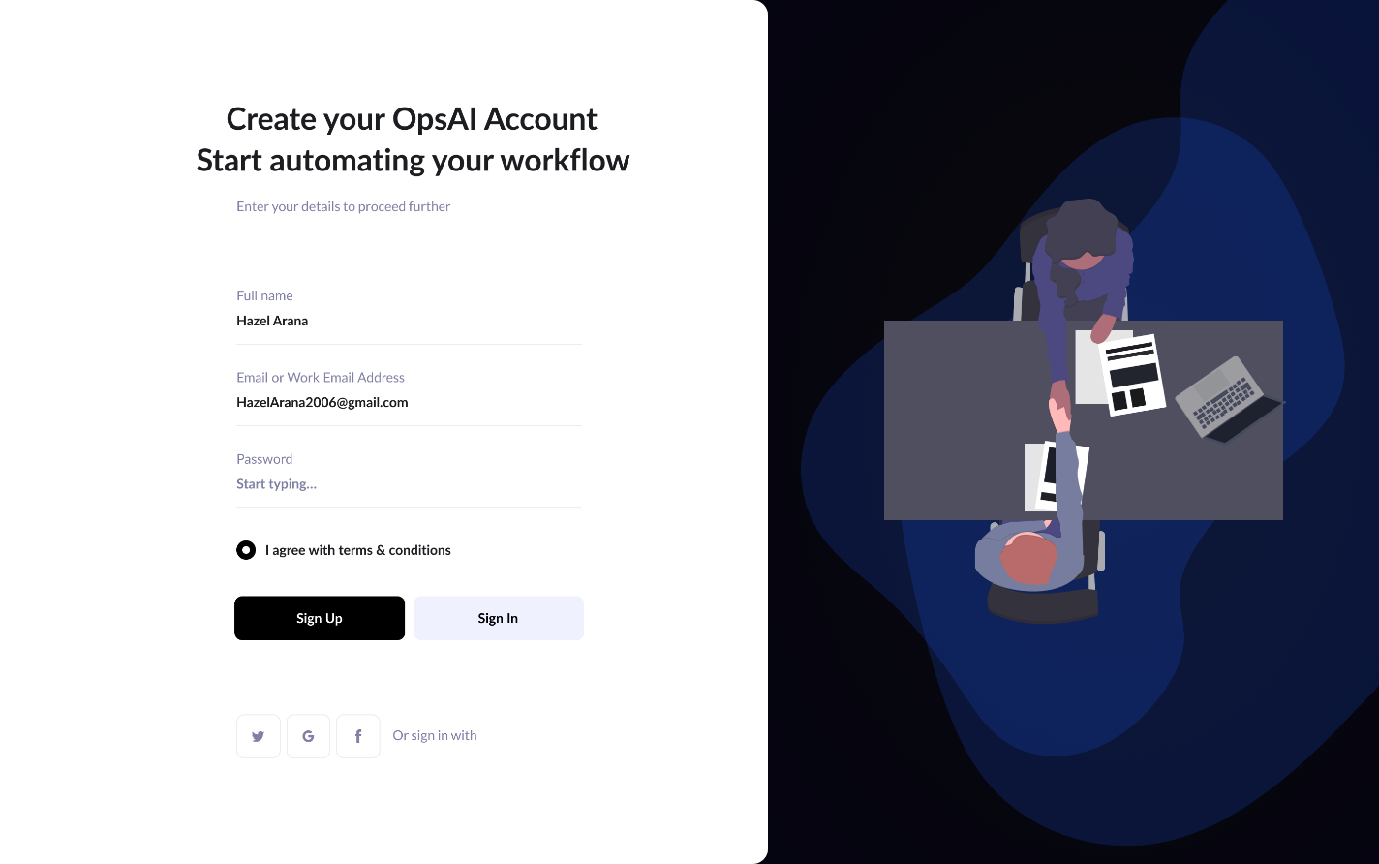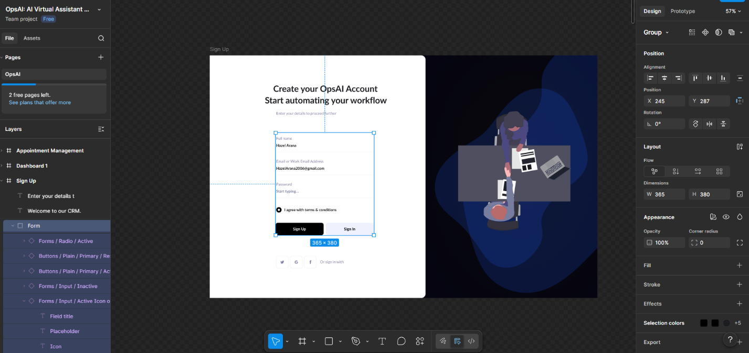
This screen allows users to securely access the OpsAI SaaS platform using a clean, distraction-free authentication form. It includes clear input fields and a prominent login button, minimizing friction and cognitive load during the entry process.
Figure 2 – OpsAI Main Dashboard
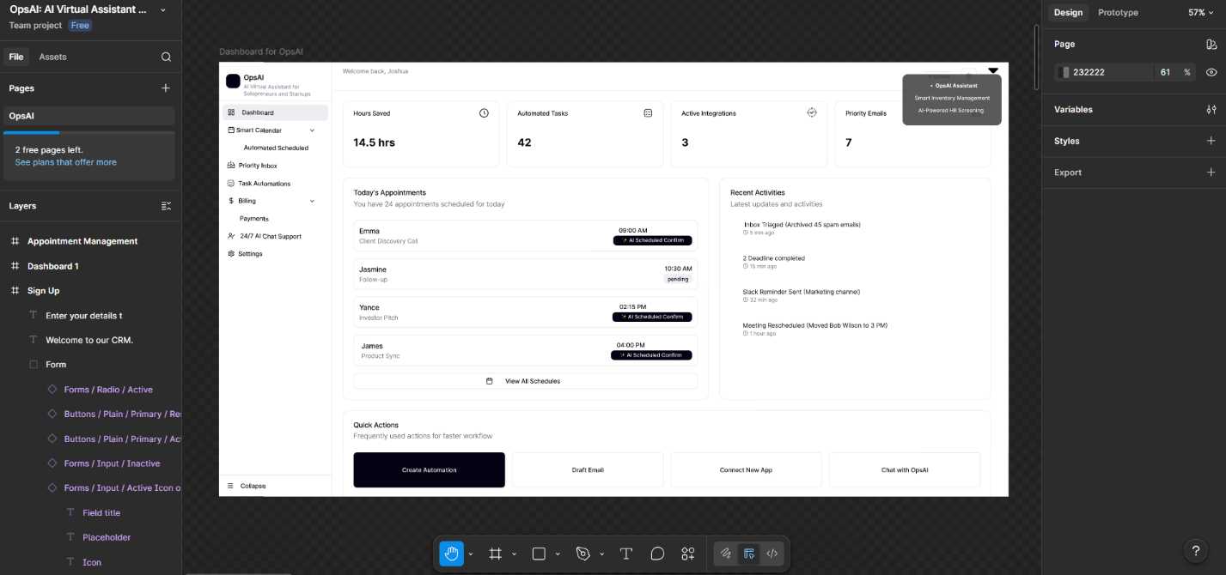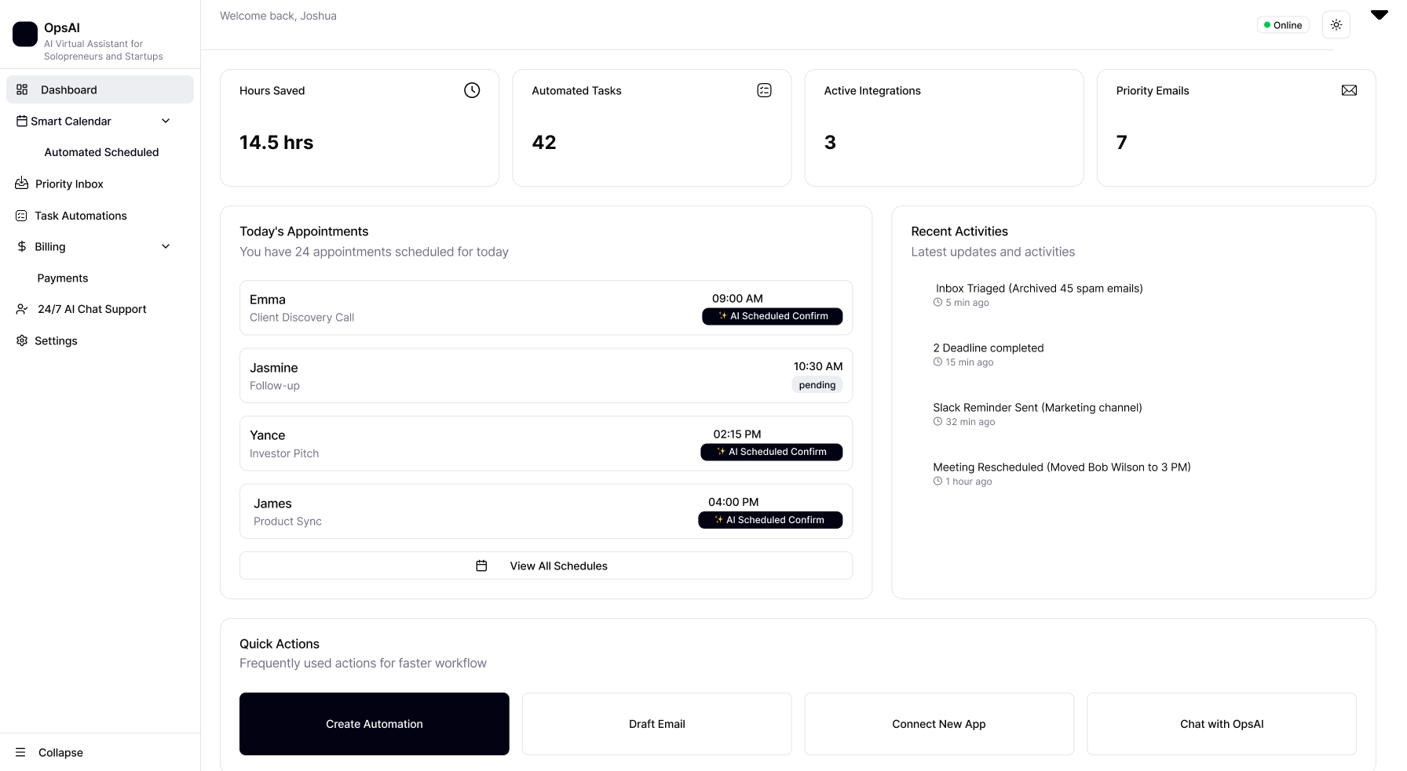
This screen serves as the primary hub of the SaaS platform, featuring a persistent navigation menu on the left and a quick-glance layout. It organizes daily tasks, system overviews, and recent activity into digestible cards, allowing users to navigate operational data effortlessly without feeling overwhelmed.
Figure 3 – Smart Inventory Management Page
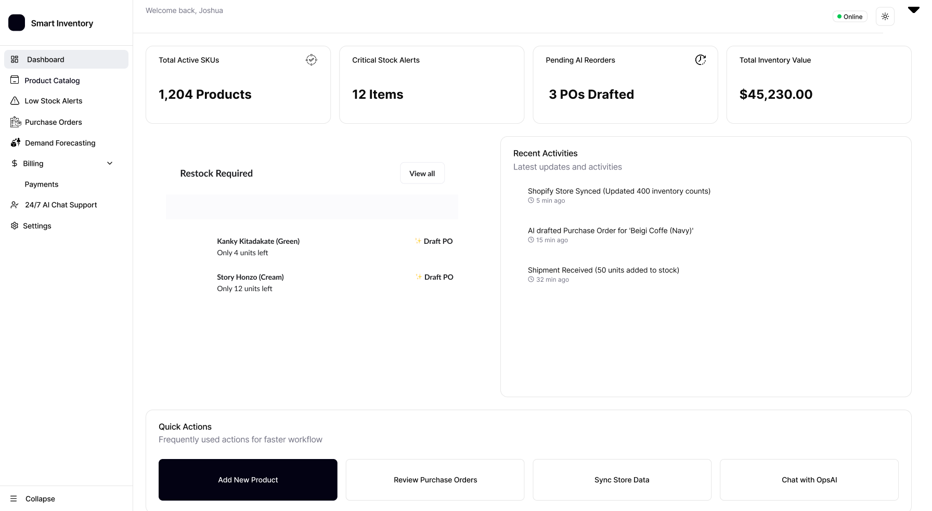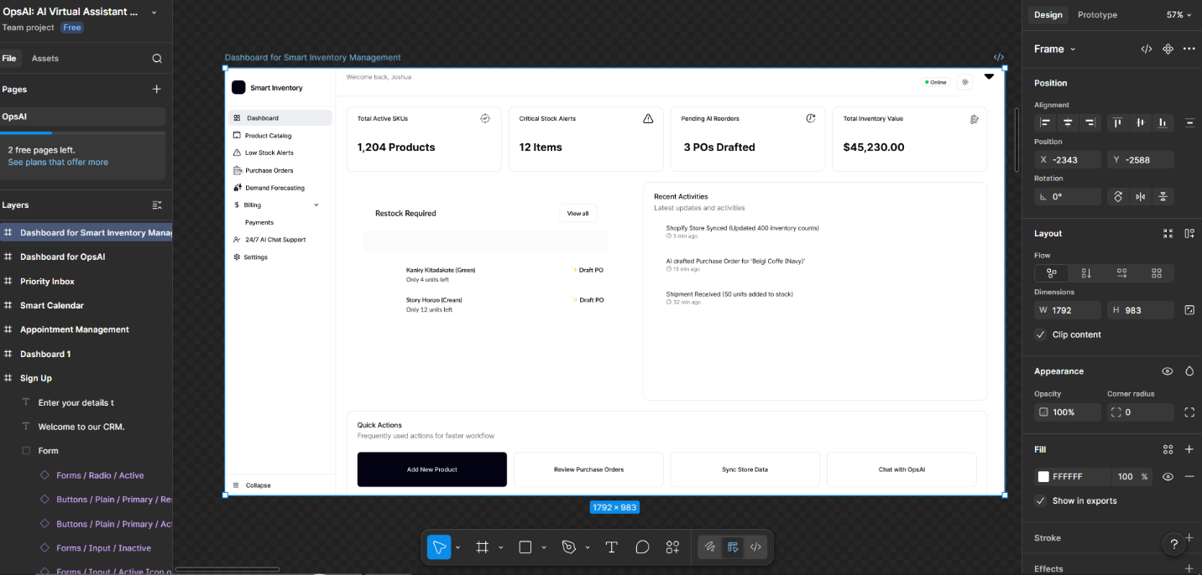
This data entry and management page allows users to add new resources and monitor stock levels in a structured data table. It uses color-coded status badges (green for in-stock, red for out-of-stock) to provide immediate, emotionally reassuring feedback on inventory health, adhering to standard usability principles.

